**Train Forms**

**Passenger Form**

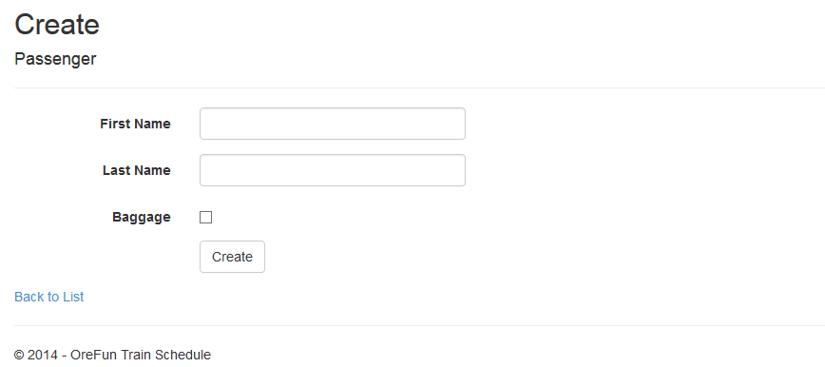

**Route Form (multi table form from Station and Route)**

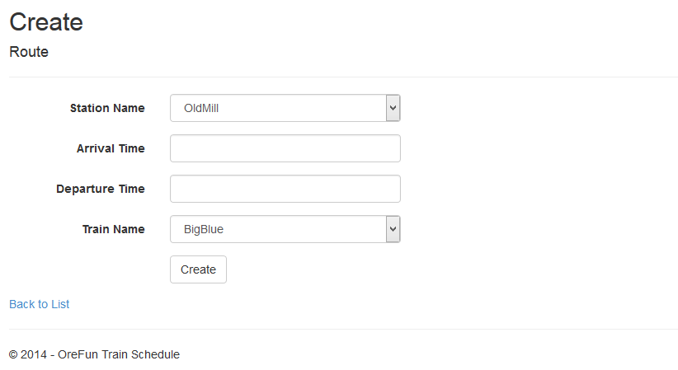

**Ticket Form (multi table form from ticket, route, and passenger tables)**

